**BANK LOAN REPORT QUERY DOCUMENT**

KPI’s:

--Total Loan Application

SELECT COUNT(id) Total_Application FROM financial_loan



--MTD(month-to-day) Total Loan Application

SELECT COUNT(id) MTD_Total_Application FROM financial_loan

WHERE MONTH(issue_date) = 12 AND YEAR(issue_date) = 2021

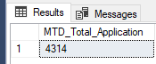

--PMTD(previous-month-to-day) Total Loan Application

SELECT COUNT(id) PMTD_Total_Application FROM financial_loan

WHERE MONTH(issue_date) = 11 AND YEAR(issue_date) = 2021

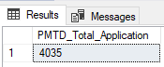

-- For calculate to Month-to-Month(MoM) rate use this formula: (MTD-PMTD)/PMTD

------------------------------------------------------------------------------------------------

--Total Loan Application

SELECT COUNT(id) Total_Application FROM financial_loan



--MTD(month-to-day) Total Loan Application

SELECT COUNT(id) MTD_Total_Application FROM financial_loan

WHERE MONTH(issue_date) = 12 AND YEAR(issue_date) = 2021

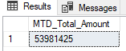

--PMTD(previous-month-to-day) Total Loan Application

SELECT COUNT(id) PMTD_Total_Application FROM financial_loan

WHERE MONTH(issue_date) = 11 AND YEAR(issue_date) = 2021

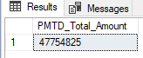

------------------------------------------------------------------------------------------------

--Total Amount Recieved

SELECT SUM(total_payment) Total_Recieved FROM financial_loan



--MTD(month-to-day) Total Amount Recieved

SELECT SUM(total_payment) MTD_Total_Recieved FROM financial_loan

WHERE MONTH(issue_date) = 12 AND YEAR(issue_date) = 2021



--PMTD(previous-month-to-day) Total Amount Recieved

SELECT SUM(total_payment) PMTD_Total_Recieved FROM financial_loan

WHERE MONTH(issue_date) = 11 AND YEAR(issue_date) = 2021



------------------------------------------------------------------------------------------------

--Average Interest Rate

SELECT AVG(int_rate) Avg_Rate FROM financial_loan



--MTD(month-to-day) Average Interest Rate

SELECT AVG(int_rate) MTD_Avg_Rate FROM financial_loan

WHERE MONTH(issue_date) = 12 AND YEAR(issue_date) = 2021



--PMTD(previous-month-to-day) Average Interest Rate

SELECT AVG(int_rate) PMTD_Avg_Rate FROM financial_loan

WHERE MONTH(issue_date) = 11 AND YEAR(issue_date) = 2021



------------------------------------------------------------------------------------------------

--Average Debt-to-Income Ratio (DTI)

SELECT AVG(dti) * 100 Avg_DTI FROM financial_loan



--MTD(month-to-day)Average Debt-to-Income Ratio (DTI)

SELECT AVG(dti) * 100 MTD_Avg_DTI FROM financial_loan

WHERE MONTH(issue_date) = 12 AND YEAR(issue_date) = 2021



--PMTD(previous-month-to-day) Average Debt-to-Income Ratio (DTI)

SELECT AVG(dti) * 100 PMTD_Avg_DTI FROM financial_loan

WHERE MONTH(issue_date) = 11 AND YEAR(issue_date) = 2021



------------------------------------------------------------------------------------------------

SELECT DISTINCT loan_status FROM financial_loan

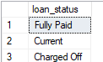

--Fully Paid and Current shows us good loan and Charged Off shows us bad loan

--GOOD LOAN ISSUES

--Good Loan(GL) Application's Percentage

SELECT

(COUNT(CASE WHEN loan_status = 'Fully Paid' OR loan_status = 'Current' THEN id END) * 100.0)

/

COUNT(id) AS GL_Percentage

FROM financial_loan



--Good Loan(GL) Aplication

SELECT COUNT(id) AS GL_Application FROM financial_loan

WHERE loan_status = 'Fully Paid' OR loan_status = 'Current'



--Good Loan(GL) Founded Amount

SELECT SUM(loan_amount) AS GL_Founded_Amount FROM financial_loan

WHERE loan_status = 'Fully Paid' OR loan_status = 'Current'



--Good Loan(GL) Total Recieved Amount

SELECT SUM(total_payment) AS GL_Recieved_Amount FROM financial_loan

WHERE loan_status = 'Fully Paid' OR loan_status = 'Current'



------------------------------------------------------------------------------------------------

--BAD LOAN ISSUES

--Bad Loan(BL) Application's Percentage

SELECT

(COUNT(CASE WHEN loan_status = 'Charged Off' THEN id END) * 100.0)

/

COUNT(id) AS BL_Percentage

FROM financial_loan



--Bad Loan(BL) Aplication

SELECT COUNT(id) AS BL_Application FROM financial_loan

WHERE loan_status = 'Charged Off'



--Bad Loan(BL) Founded Amount

SELECT SUM(loan_amount) AS BL_Founded_Amount FROM financial_loan

WHERE loan_status = 'Charged Off'



--Bad Loan(BL) Total Recieved Amount

SELECT SUM(total_payment) AS BL_Recieved_Amount FROM financial_loan

WHERE loan_status = 'Charged Off'



------------------------------------------------------------------------------------------------

--LOAN STATUS

SELECT

loan_status,

COUNT(id) loan_count,

SUM(total_payment) Recieved_Amount,

SUM(loan_amount) Founded_Amount,

AVG(int_rate)*100 interest_rate,

AVG(dti)*100 dti_rate,

ROUND(AVG(annual_income),2) avg_annual_income

FROM financial_loan

GROUP BY loan_status

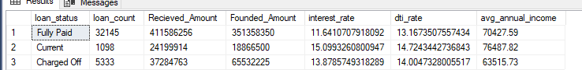

------------------------------------------------------------------------------------------------

SELECT

loan_status,

SUM(total_payment) MTD_Recieved_Amount,

SUM(loan_amount) MTD_Founded_Amount

FROM financial_loan

WHERE MONTH(issue_date) = 11

GROUP BY loan_status

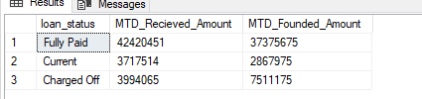

------------------------------------------------------------------------------------------------

--Monthly Trends by Issues Date

SELECT

MONTH(issue_date) Month_Number,

DATENAME(MONTH,issue_date) Months,

COUNT(id) Loan_Application,

SUM(loan_amount) Total_Founded_Amount,

SUM(total_payment) Total_Recieved_Amount

FROM financial_loan

GROUP BY MONTH(issue_date), DATENAME(MONTH,issue_date)

ORDER BY MONTH(issue_date)

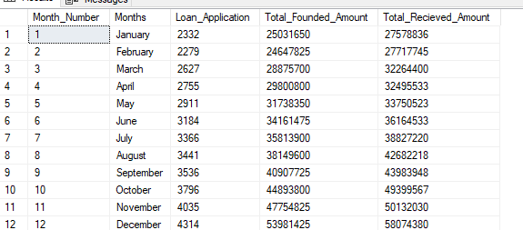

------------------------------------------------------------------------------------------------

--Regional Analysis by State

SELECT

address_state,

COUNT(id) Loan_Application,

SUM(loan_amount) Total_Founded_Amount,

SUM(total_payment) Total_Recieved_Amount

FROM financial_loan

GROUP BY address_state

ORDER BY SUM(loan_amount) DESC

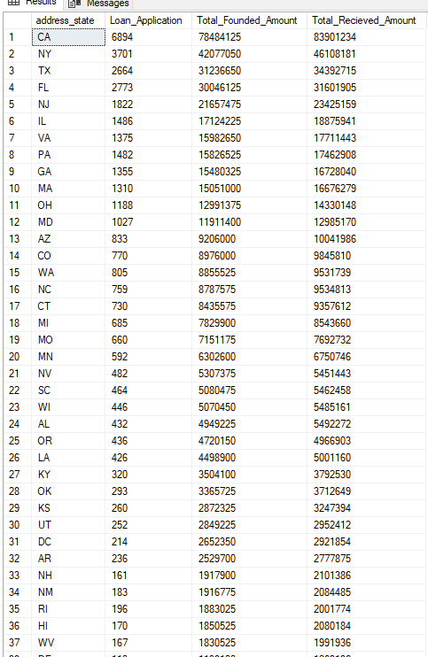

------------------------------------------------------------------------------------------------

--Loan Term Analysis

SELECT

term,

COUNT(id) Loan_Application,

SUM(loan_amount) Total_Founded_Amount,

SUM(total_payment) Total_Recieved_Amount

FROM financial_loan

GROUP BY term

ORDER BY term



------------------------------------------------------------------------------------------------

--Employee Length Analysis

SELECT

emp_length,

COUNT(id) Loan_Application,

SUM(loan_amount) Total_Founded_Amount,

SUM(total_payment) Total_Recieved_Amount

FROM financial_loan

GROUP BY emp_length

ORDER BY COUNT(id) DESC

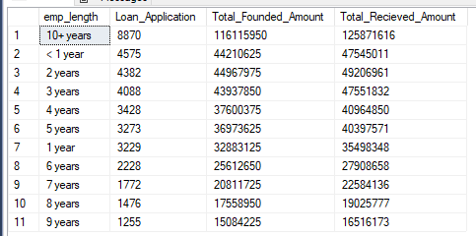

------------------------------------------------------------------------------------------------

--Loan Purpose Breakdown

SELECT

purpose,

COUNT(id) Loan_Application,

SUM(loan_amount) Total_Founded_Amount,

SUM(total_payment) Total_Recieved_Amount

FROM financial_loan

GROUP BY purpose

ORDER BY COUNT(id) DESC

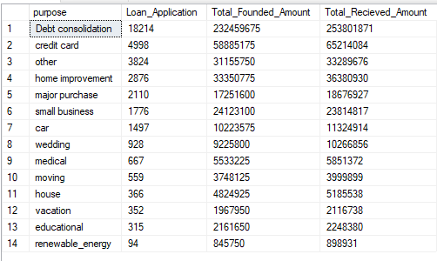

------------------------------------------------------------------------------------------------

--Home Ownership Analysis

SELECT

home_ownership,

COUNT(id) Loan_Application,

SUM(loan_amount) Total_Founded_Amount,

SUM(total_payment) Total_Recieved_Amount

FROM financial_loan

GROUP BY home_ownership

ORDER BY COUNT(id) DESC

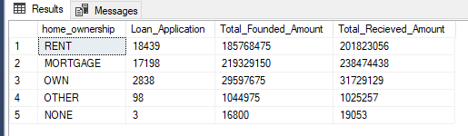

------------------------------------------------------------------------------------------------

Note: We can check the results for the filters as well by modifying the query and comparing the results.

* See the results when we hit the Grade A in the filters for dashboards.

SELECT

purpose,

COUNT(id) Loan_Applications,

SUM(loan_amount) Total_Funded_Amount,

SUM(total_payment) Total_Amount_Received

FROM financial_loan

WHERE grade = 'A'

GROUP BY purpose

ORDER BY purpose

